Element of Culture
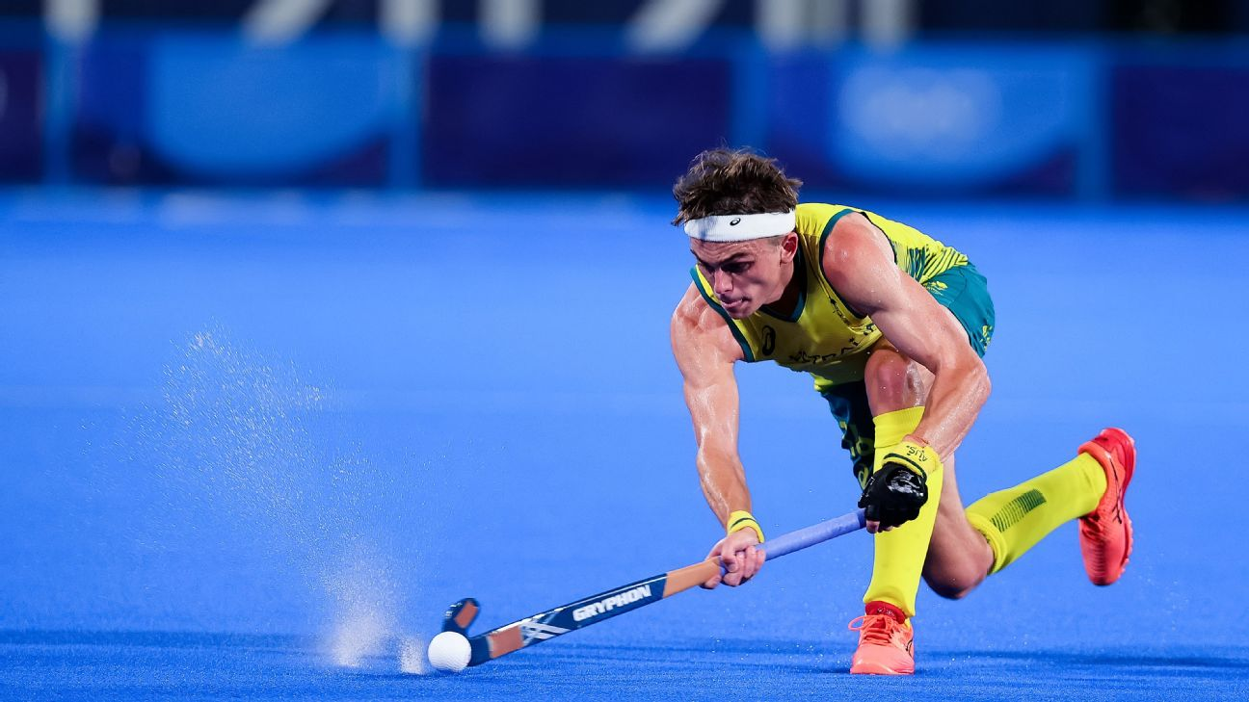
Hockey
Ashton George

Table of contents
- Introduction

- Origin and dispersal
  - Origin
  - Dispersal

- Diffusion
  - Role played by transnational corporations
  - advancements in transport telecommunications

- Case studies
  - Adaptive Hockey in the Netherlands
  - Upper Great Southern Hockey Association

- Implications
  - Positive
  - Negative

- Future Changes
  - Nature
  - Spatial Distribution

- Conclusion

- Bibliography

1.0 Introduction
Culture is a term that encompasses the social behaviour and norms found in human societies, as well as the knowledge, beliefs, arts, laws, customs, capabilities, and habits of the individuals in these groups. Elements of culture can include fashion, religion, language, architecture, political and social ideas, and sport. This report will outline hockey as an element of culture. The areas of hockey that will be discussed include origin and dispersal overtime, factors contributing to the diffusion, case studies, implications of the changes in nature and spatial distribution, and likely futures changes in the nature and spatial distribution.

2.0 Origin and dispersal 2.1 Origin
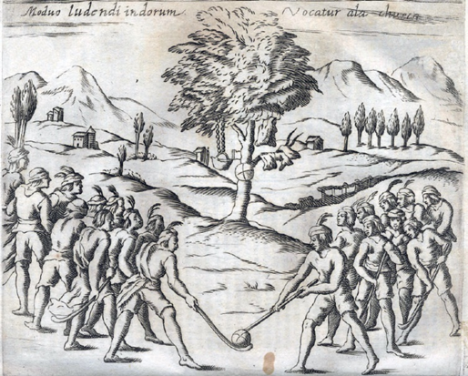
Early forms games that featured sticks like hockey originated in the ancient world up to 2000BC. These early forms of hockey come from ancient civilizations in countries such as Egypt, Ethiopia, Iran, Rome, Greek, Aztec, Arab, Africa, South America, Ireland and Mongolia. Some of these early games include hurling in Ireland (1272BC), Beikou in Mongolia (1000 years ago) and Chueca from south America specifically Chile (16th century seen in figure 2.1).
Figure 2.1. Native chileans Playing chuace
Even though hockey like games originated in these ancient communities, modern hockey originated in England. It was played and developed in the English public school system in the mid-18th to early 19th centuries
2.2 Dispersal
The first hockey club in the world was established in 1861, this club was named Blackheath & Old Elthamians Hockey Club. In 1876 an attempt to consolidate hockey as a formal sport led to the first association being established. This association was responsible for drawing up the first formal set of hockey rule but only lasted 6 years. 10 years after this first association was created another was made in London in 1886 being revived from its earlier counterpart.
As the British empire grew so did hockey’s popularity throughout the world. British soldiers used hockey as a cultural bridge between settlers and locals. A prominent example of one of these countries is India. The first international hockey match was held between British soldiers and Ireland playing together to defeat Wale three to nil in 1895. Soon after hockey was first introduced into the Olympic games in London 1908 but only a men’s competition was added. After the 1924 Paris Olympic games where hockey was not included the International Hockey Federation (FIH) was founded. The FIH was introduced to represent hockey in the founder’s countries Austria, Belgium, Czechoslovakia, France, Hungary, Spain, and Switzerland. Now the FIH represents around 91 countries. In 1980 at the Moscow games women’s hockey was finally introduced 72 years after men’s hockey was introduced.

3.0 Diffusion
3.1 Role played by transnational corporations
Gryphon Hockey
Gryphon hockey is an international corporation founded in Perth Western Australian in the late 1970’s. Gryphon hockey has partnered with organisations to help people in less developed countries gain access to equipment and coaches to enable them to play hockey.
In 2018 Gryphon partnered up with Hockey Dreams Foundation whose focus is “to make an impact within our sport (hockey) and support the development of sustainable communities”. Gryphon works on a project with them that aims to give hundreds of children in African countries the opportunity to play hockey, who otherwise may not. They do this by running clinics for local children, training locals to be able to coach and donating hundreds of sticks, bags, and apparel. Gryphon at the moment mainly focuses on helping communities in Zambia play the sport.
Gryphon has also partnered with Hockey Dreams Foundation, as well as the Timor Leste Hockey Federation on a recycling programme in 2019. This programme gets Australian Gryphon ambassadors that use a considerable amount of equipment throughout the year such as Tim Howard to donate their gear which is still in useable condition. Howard says that “It's amazing as quite often we would go through 5 or 6 sticks in a year, however they would still be in condition for someone else to use”. The donated gear is sent to Timor Leste where children are given access to it and the opportunity to learn hockey. Because of the donations hockey has grown to become a popular sport within the country, with Hockey Timor Leste becoming officially registered at the registration and notary of Timor Leste as a national sporting body.

3.2 Advancements in transport telecommunications
Containerisation
Containerisation is the transportation of cargo in containers, that can be interchanged between ships, trains, and trucks, it has the standardised handling of equipment without rehandling the containers. This allows for equipment, such as sticks, balls and shin pads, that are essential for player to be shipped from anywhere in the world to anywhere. Gryphon hockey uses containerisation to as it manufactures its sticks in Pakistan and sells worldwide to countries such as Australia and the Netherlands. Atlas, arguably the world’s largest hockey stick producer in the world, manufactures their sticks in Taiwan, packages them in China and ships them all over the world.
Airplanes
Airplanes were invented in the twentieth century and have been helping people to cut the time taken to travel across land and sea. Airplanes allow for players on national teams to travel to compete in international tournaments such as the Olympics and FIH pro league. As well as the players it also allows fans to follow teams to these tournaments to watch and barrack for their team.

4.0 Case studies
4.1 Adaptive hockey in the Netherlands
The Royal Dutch Hockey Association (KNHB) has put in place two initiatives for players with learning and physical disabilities, and for players with electric and hand moved wheelchairs. The KNHB is aiming for “The integration of able and disabled hockey players within out hockey clubs” and “the provision of structural activities and support for players with a disability”. The KNHB puts on many activities throughout the year for the two initiatives including national tournaments, league games, annual tournaments, friendly matches, and social activities. They have been trying to get the adaption of the sport to become international but have found some challenges with international co-operation’s and recognition, only having 3 teams from Belgium being regular participants. Despite this they have strong numbers in the Netherlands with 62 clubs offering learning disability hockey, 12 clubs offering physical disability hockey, two offering both, and electric wheelchair hockey having 5 leagues with 60 teams from 27 clubs and hand moved wheelchair hockey with 7 leagues from 22 clubs, as of 2010.

4.2 Upper Great Southern Hockey Association
The Upper Great Southern Hockey Association (UGSHA) is the hockey association that encompasses the lower portion of the wheatbelt and upper portion of the great southern regions of Western Australia. The association is based in the town of Narrogin with teams coming from Williams, Brookton, Wagin, Wickepin, Pingelly Dumbleyung, and Woodanilling (joined the most recently in the 2021 season) (https://www.scribblemaps.com/create/#id=UGSHA a link to a map that show where hockey is played in the upper great southern). All teams play on Narrogin’s synthetic turf which was put in place in 2016 (Figure 4.1). The hockey season runs throughout the winter months with the senior competitions including both men’s and women’s A and B grades and the Junior competitions including school ages from pre-primary to year 12 with 5 competitions Stick2Hockey (pre-primary-year 1), J7 (Years 2-4), J11 (Years 4-6), Middle school (Years 7-9) and upper school (Years 10-12). UGSHA often sends teams away to compete in tournaments against teams from other associations. These competitions include country week (Usually a three-day men’s and women’s tournament against other country teams), club champs (A tournament for high school aged children divided into 3 age groups) and Bunbury carnival (Arguably the biggest junior tournament in the southern hemisphere).
UGSHA also holds many of its own events throughout the year. Its biggest being a two-day junior carnival for years 5-10 held every July, it attracts teams from north of Narrogin such as Perth to south of Narrogin like Esperance. They regularly hold clinics inviting elite players from the Hockey Roos and Kookaburras to teach local children new skills. They also make an event out of their grand finals encouraging everyone from the community to get involved, drawing large crowds.

5.0 Implications
5.1 Positive
Locally hockey can have huge benefits on the economy with events such as tournaments bringing many visitors and tourists to towns who will spend their money. These people end up spending money on accommodation, food, travel, and entertainment. Hockey also positively impacts peoples social and physical health. Physically hockey brings along all of the benefits of most sports such as increased body strength, developed cardiovascular system and increased co-ordination skills. Socially hockey helps people improve teamwork and communication skills that can help players on and off the field.
5.2 Negative
Negative implications hockey has on people is the cost. Hockey is sometime considered to be a sport for ‘wealthy’ countries as the fees to play the sport can add up to be quite a lot. It has been reported that in average parents can spend up to $2000 annually to let their children play hockey. The costs that add up to this large number include equipment such as sticks, shin pads, mouthguards, masks, gloves, bags, shoes and uniforms as well as other cost such as transport, accommodation, tournament fees and club fees. A negative impact on the environment is the amount of water that is used to maintain synthetic turfs which in dry conditions can use up to one litter of water per square meter every hour. With hockey fields being 91 meters by 55 meters a turf can use up to 5027 litters of water per hours it is being used.

6.0 Future changes
6.1 Nature
Likely future changes in the nature of hockey include the improved quality of the game, more adaptions, rule changes and hockey becoming more inclusive. In the future the quality of hockey will improve as more and more synthetic turfs are installed replacing grass fields making games flow better and the grounds needing less maintenance. As hockey is diffused further throughout the world and more people start to play it more adaptions of the game may occur. These adaptions may be due to hockey being played in new environments or due to the needs of the people playing it. These adaptions to the game could also lead to rule changes within the sport. The rules of the game are regularly reviewed before each season with rules often being added, removed, or even modified. An example of this is before the 2020 season it was made that players could no longer be as close as possible inside their defensive D to an opposition player taking a free hit outside the D, they now had to be 5 meters. Lastly in the changes in nature it is likely that more ages will be included into local competitions. In Australia, state hockey already including ‘masters’ completions with divisions for ages 35 through to 75 plus increasing intervals of 10.

6.2 Spatial distribution
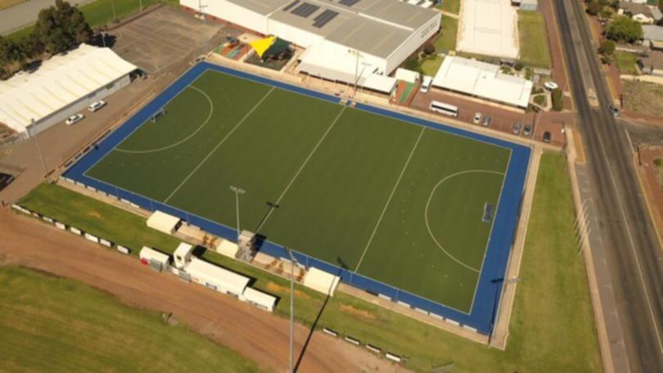
The first likely changes in spatial distribution is the integration of more high-quality synthetic turfs throughout rural areas. This has been starting to happen throughout the wheatbelt of Western Australia where Narrogin (figure 6.1) and Northam have installed high quality turfs in 2016 and 2019. Along with this higher levels of hockey will be played outside of cities and in more rural areas. This has already stated to happen with Narrogin hosting 2 international games on their turf, the Kookaburras against Great Britain in 2016 and the Kookaburras against the Netherlands in 2018. Hockey will also become a sport accessible for more people to play and not just for people from ‘wealthy’ countries. Hopefully the costs of equipment coming down and the donation of equipment will help with this.
Figure 6.1. Narrogin’s synthetic hockey turf.
- Conclusion
In conclusion the modern game of hockey originated in England dispersing throughout the world as the British empire grew, two factors that have contributed to the diffusion of hockey is the role played by transnational corporations and advancements in transport telecommunications, the Netherlands and the Upper Great Southern Hockey Association are two example of places that have embraced hockey as an element of their culture, there are both positive and negative implications of playing hockey and there are many likely future changes going to happen to the sport.

Bibliography
A Hockey World. 2021. The History Of Field Hockey: The Origins Of The Game. [online] Available at: <https://www.ahockeyworld.net/where-was-field-hockey-invented/> [Accessed 23 July 2021].
Brasch, M., 2002. The Macmillan Encyclopaedia of Australian Sports. 3rd ed. South Yarra: MACMILLAN EDUCTAION AUSTRLIA PTY LTD, pp.6-7.
Fih.ch. 2021. History of Hockey | FIH. [online] Available at: <http://www.fih.ch/hockey-basics/history/> [Accessed 23 July 2021].
Fih.ch. 2010. “G” AND “LG” HOCKEY IN THE NETHERLANDS. [online] Available at: <http://www.fih.ch/media/359484/g-lg-e-h-hockey-netherlands.pdf> [Accessed 30 August 2021].
Griffin, A., 2018. WA ATAR geography. Subiaco, Western Australia: Geographical Association of western Australia.
Gryphonhockey.com. 2020. Gryphon Recycle Program in Australia. [online] Available at: <https://www.gryphonhockey.com/post/recycle-program-australia> [Accessed 9 September 2021].
Gryphonhockey.com. 2020. Make a difference through the power of sports. [online] Available at: <https://www.gryphonhockey.com/post/make-a-difference-through-the-power-of-sports> [Accessed 9 September 2021].
Revolutionise.com.au. 2021. About. [online] Available at: <https://www.revolutionise.com.au/ugsha/about/> [Accessed 26 August 2021].
Smith, S., 2021. The Origins Of The Hockey Museum. [online] Hockeymuseum.net. Available at: <http://www.hockeymuseum.net/index.php/2015-05-27-14-12-31/the-origins-of-the-hockey-museum> [Accessed 28 July 2021]

Photo 1: Native Chileans Playing chuace. Retrieved from
Photo 2: Narrogin’s synthetic hockey turf. Retrieved from https://www.narroginobserver.com.au/news/narrogin-observer/close-contests-and-plenty-of-goals-in-round-two-of-ugsha-ng-b881600914z

